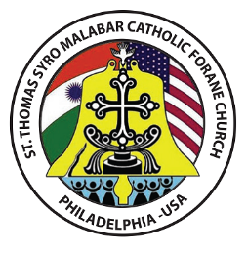
School of Religious Education
ST. Thomas Syro-Malabar Catholic Forane Church
(ST. Thomas Syro-Malabar Diocese of Chicago)
608 Welsh Rd. Philadelphia, PA 19115

Please type and replace the colored field values with your information
Church Family ID#: | Family ID |  | Grade |  |  | Grade
Student’s name: | First Name |  | Middle Name |  |  | Last Name
Street | City |  | State |  |  | Zip
Phone | Phone |  | Email |  |  | Email
Date of Birth | Date of Birth |  | Date of Baptism |  |  | Date of Baptism
Place of Birth | Place of Birth
Parish where Baptized | Parish where Baptized
Name of Previous School attended | Previous School
 | Information of Father |  |  | Information of Mother
Family Name | Family Name |  |  | Family Name
Name | Name |  |  | Name
Cell Phone | Cell Phone |  |  | Cell Phone
Email | Email |  |  | Email
Place of Birth | Place of Birth |  |  | Place of Birth
Parish in India | Parish in India |  |  | Parish in India
Diocese in India | Diocese in India |  |  | Diocese in India
Rite | Rite |  |  | Rite
Two emergency contacts other than parents
Name |  | Phone Number |  |  | Relationship to the Child
Contact Name |  | Phone Number |  |  | Relationship
Contact Name |  | Phone Number |  |  | Relationship
Please note that the classes will start on Sep.11, Please complete your registration before Aug. 28.
Registration Fees: 1 Child $80, 2 Children $135, 3 or more Children $165; Due at the time of registration. Please provide a copy of the Baptism certificate for new registration. You may pay the fees at faith direct using the link: https://membership.faithdirect.net/givenow/PA1087/39323
REGISTRATION FORM

