FAITHFEST 2017
YOUNG ARTISTS’ COMPETITION
Date & Time of Competition: Saturday February 25 @ 10:00 am
Max. Time allowed: 1 hour
Coloring: Group 1 (Grades Pre-K, KG & 1):- February 25 at 10 am
Pencil drawing: Groups 1, 2 & 3 (Grades Pre-K to 8): February 25 at 10 am
Painting: Group 1, 2 & 3 (Grades Pre-K to 8): February 25 at 10 am

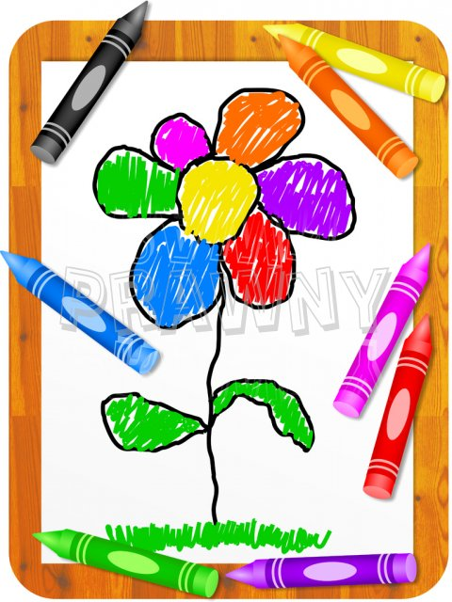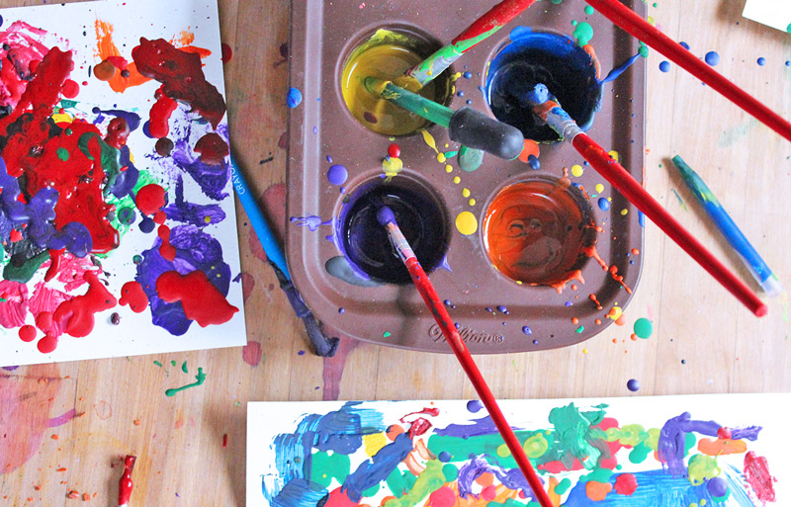
What the contestants MUST bring to the competition:
Coloring : Crayons, NO MARKERS. Picture will be given.
Pencil Drawing/Sketching : 2 pencils, eraser, color pencils, sketch paper, NO MARKERS
Painting-Water color: paint kit, paint brushes, and sketch paper

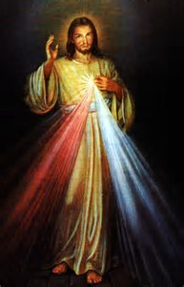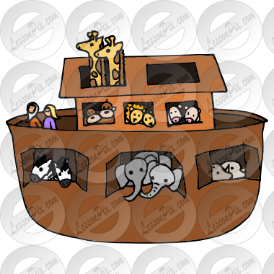
Themes for the artwork:
Pencil Drawing/Sketching:
Group 1: Easter flowers
Group 2: Baptism of Jesus at river Jordan (Matthew 3:13 – 17)
Group 3: Crucifixion of Christ at Calvary (Luke 23: 33)

Painting - Water color:
Group 1: Noah’s ark (Genesis Chapter 6 – 10)
Group 2: Jesus Christ - the son of God (Mathew 16:15 -17)
Group 3: Jesus –the Good Shepherd (John 10: 14)

